Northwestern University Behavioral Phenotyping Center
Facilities and Other resources
The Northwestern University Behavioral Phenotyping Core (BPC) presently occupies a suite of five rooms (1160 sq ft total space) within the Ward Building on the Chicago campus. The suite includes separate animal holding rooms for rats (145 sq ft) and mice (160 sq ft), a room for surgery (120 sq ft) that is time-shared for rats and mice (overflow space is available across the street in the Lurie Building which is connected to the Ward building by a tunnel); The Ward building surgical space has separate areas for preparation, operation and recovery. The suite also has rooms for testing rat behaviors (205 sq ft), a larger room with isolation chambers from Industrial Acoustics Corporation (IAC) to test mouse behaviors (248 sq ft), a room for using the mouse water maze (100 sq ft), and one other room for using the rat water maze (132 sq ft).
The BPC is organized to test cognition, sensory / motor abilities, anxiety, and pain. We are planning to add tests of executive functions and to measure ultrasonic vocalizations and depression. The Core is designed so that independent investigators can use the various behavioral testing and surgical stations simultaneously. This allows efficient use of the space provided and has been accomplished by using the. IAC isolation chambers and drapes to isolate larger areas.
The BPC provides training and protocols for investigators to get IACUC approval for their studies. Several Approved Animal Protocols (AAPs) are already in place and can be readily added by a Principal Investigator to their approved Animal Study Protocol (ASP). AAPs allow for much more rapid approval by the IACUC of a PI’s animal protocol that is being modified to include behavioral testing.
The BPC can perform a general physical exam, gait analysis, and measures of general ambulation. Several tests of learning and memory are offered (see list of Equipment), and tests of anxiety, pain and depression have been offered. A stereotaxic device with rat and mouse head-holders is provided as is an isoflurane vaporizer for gaseous anesthesia.
The following equipment is available in the BPC: Actimetrics water maze system, Actimetrics FreezeFrame fear conditioning system, custom eyeblink conditioning system, Actimetrics LimeLight system for analyzing behavior in open fields and mazes (zero maze and Y maze), Mouse Specifics DigiGait for gait analysis, Med Associates startle response system for examining prepulse inhibition, Ugo Basille thermal plantar device to measure temperature sensitivity, a set of von Frey filaments to measure touch sensitivity, and a TSE rotorod for mice to assess coordination of gait. Most of the assays in the Core provide Excel compatible output files.

Equipment
Our basic mazes were made by Phenome Technologies (Lincolnshire, Il) and we use Actimetrics software (Willmette, IL) to collect ambulation data.

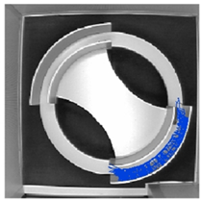
Zero Maze: The zero maze tests for anxiety. The maze consists of a round track (56 cm diameter) that is divided into four sections of equal area by two sets of walls along the track. The two regions with walls are separated by 180 degrees around the track. A mouse is placed on the track near the border of the open and closed region and examined for latencies and durations to enter/explore the exposed parts of the track. An anxious mouse will avoid the open regions of the track. LimeLight software (Actimetrics) is used to collect data for a five minute session. The software calculates the percent of time in the open or closed portions of the track. The zero maze is a recent improvement of the more common elevated plus maze; it avoids the ambiguous open/closed area at the center of the elevated plus maze (Cook et al., 2002, PMID: 12036108; Kulkarni et al., 2007, PMID: 17805436).

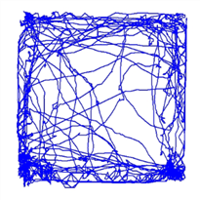
Open Field: This arena (56 x 56 cm) is used to assess ambulation levels as well as anxiety. The mouse is placed in the center of the arena and its ambulation activity is collected by the LimeLight software for five minutes. The software provides the total distance traveled as well as the percentage of time/distance within different parts of the arena. Any number of zones can be defined. An anxious mouse will spend more of its time along the perimeter of the arena. A hyperactive mouse will have a large ambulation score. Hsiao et al. (1995, PMID: 7576662) used this task to differentiate transgenic mice carrying the APP gene from wild type mice. Transgenic mice tended to stay within the center of the arena and exhibited neophobia. Aging mice also tend to have less exploration in the open field than younger mice (Weiss, Shroff & Disterhoft, 1998, Neurosci. Res. Comm. 23 (2): 77-92). An example of the activity from one mouse is shown.

The open field and LimeLight software are also used to test for novel object recognition, a simple test for memory of a previously explored object, and for social recognition, a test for the memory of a previously investigated conspecific, or a cage-mate.
Y maze: This arena has three identical arms that radiate from a central triangular area at 120 degrees. The mouse is placed at the base of the arm forming the stem of the Y and positioned with its nose towards the center of the maze. The mouse is observed for five minutes while it freely traverses the maze. Data are recorded with LimeLight software. The order of arm entries is analyzed for spontaneous alternation, a hippocampal-dependent behavior of rodents in which they tend not to repeat exploration of a region that has no reward (Douglas, 1975, In: The Hippocampus, Isaacson & Pribam (Eds), 2:327-361). This behavior relies on working memory and does not require any rewards or punishments.

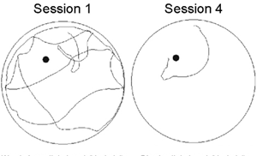
Water-maze: This task designed by Richard Morris examines spatial memory and takes advantage of the natural swimming ability of rodents and the ease of manipulating cues around the maze. The mouse is put in a pool of water (5’ diameter) and swims until an escape platform (hidden just under the surface of the water) is found; the pool for rats is 6’ diameter. If the platform is kept in the same position the mouse quickly learns to use distal cues to locate the position of the platform when the mouse is placed in the pool at different starting positions for each trial (Ohno, Sametsky, Silva & Disterhoft, 2006, PMID: 16630070). An example of the reduction in swim distance from session 1 to session 4 is shown. Data are recorded with Actimetrics WaterMaze.software.
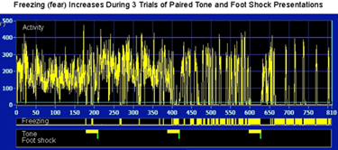
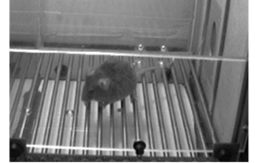
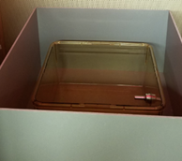
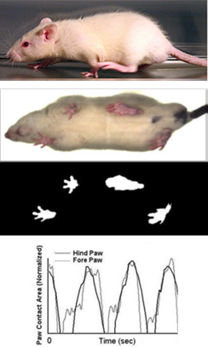
Fear Conditioning: Rodents explore a novel environment and learn to fear the environment (freeze) and cue (tone) that are present when they receive a foot shock. The task requires few trials for acquisition. Context fear is assayed approximately 24 hours after training by placing the animal back in the training chamber (far left). Cued fear is assayed by placing the animal in a novel chamber (far right) and playing the auditory cue. As shown in the center figure, contextual fear (freezing) increases after presenting the second pair of tone-shock stimuli, and fear increases after the third presentation of the stimuli (greater density of bin markers in middle histogram). Data recorded with FreezeFrame software and analyzed with FreezeView software.

Gait Analysis: (Mouse Specifics, Framingham, MA) Ventral plane imaging continuously records the underside of the rodent atop a transparent treadmill belt. Digital paw prints and dynamic gait signals are collected for analysis of each limb and paw. The areas of the advancing and retreating paws are quantified for spatial and temporal indices of gait. These signals reflect the strength, balance and coordination of the animal. Because gait varies with speed, this system allows the speed to be set by the experimenter. Gait signals (bottom right) for three different speeds are usually collected.
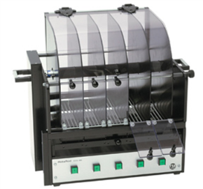
Rotarod: (TSE Systems, Chesterfield, MO) The rotorod is used to study motor coordination and fatigue. A mouse is placed into an alley and onto the center rod. Rod rotation is controlled electronically; falls are detected by light beam sensors. A maximum of five mice can be tested simultaneously. Mice are typically trained at a constant speed for 3 daily sessions and then a constant increase in acceleration to assay motor learning.
Eyeblink Conditioning (Custom hardware and software)
This is perhaps the best understood learning paradigm from a behavioral, physiological, and molecular perspective (fear conditioning is a close second). The BPC has a system to condition freely moving rats to blink to a tone while connected to a tether that transmits signals between a custom made chamber and the computer (A). We use tones or whisker vibration as the conditioning stimulus (CS) for mice and an airpuff to the eye as the unconditioned stimulus (US); EMG responses are recorded from the eyelid. Mice have their head fixed to a support while resting on a cylindrical treadmill (B, C, Heiney et al., 2014, PMID: 25378152; Lin et al. 2016, PMID: 27077752) and freely ambulate (appears to reduce stress). A piezoelectric strip is activated to drive a piece of a hair comb that straddles the whiskers to deliver the CS. The conditioned response (CR) is elicited by the CS and has an onset prior to onset of the airpuff US (D). Mice and rats will be prepared by the Surgical Core for testing in the Behavioral Core, and microphones will be installed for the USV core to collect data during training.

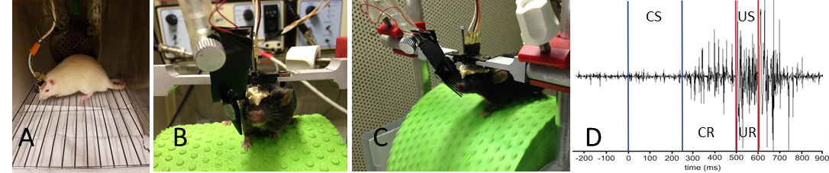
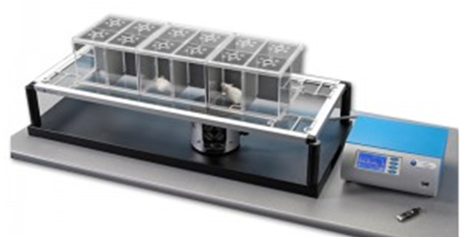
Pain Assay:(Ugo Basile, Harvard Apparatus, Holliston, MA)
The BPC has a Plantar pain test system. There are small chambers to encourage the animal to relax. A computer controlled infrared beam unit (between table and underside of platform) is positioned under the paw of each animal and the temperature of the beam gradually increases until the paw flinches. The temperature at the time of the flinch is stored in the computer.

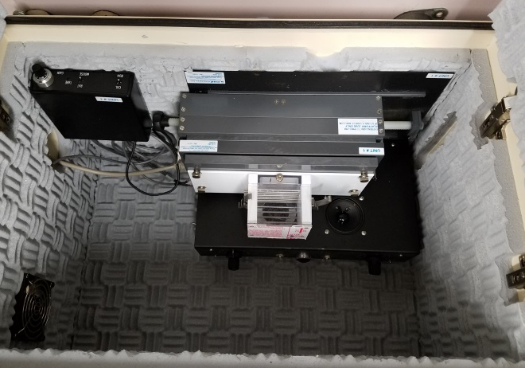
Auditory Startle and Prepulse Inhibition (PPI) of Startle: (Med Associates). The BPC has a two channel Startle system for presenting calibrated noise or pure tones to a mouse (pictured) or rat that is placed into a relatively small chamber atop a sensitive load cell. The timing, tones, and noise are preprogrammed for presentation to the subject and the output of the load cell is sent to the computer. The assay is relatively quick (about 10 minutes) so many mice can be tested in a short amount of time. PPI is a test for sensory gating, a reflex that is attenuated in those with schizophrenia.

